CSE220: Data Structures (Lab)

Fall 2024

Lab Quiz - 07

Duration: 30 Minutes

| Name: | ID: | Section: |
| --- | --- | --- |

### **Question 1 [15 Points]**

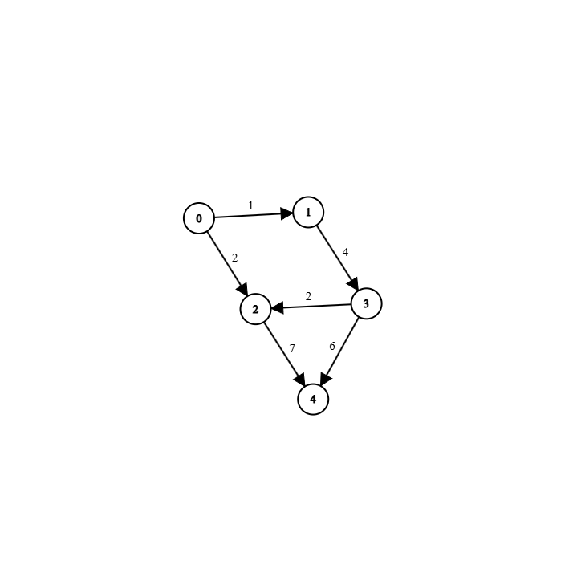

| Sample Input | 5, graph | Number of Vertices, The Graph |
| --- | --- | --- |
| Sample Output | 1, | Answer Vertex Index.  This Vertex 1 has the **lowest Outgoing edges,** and for the **same reason, Vertex 2** can also be the **answer.** |
|  | [4] | Array of Outgoing edges.   Here, **outgoing edge 4<5** which is why the Array has **4** weight.  As **vertex 2 can also be the answer** the resulting array for that case would be **[0]** because **7!<5** so the weight cannot be added to the array. |

For this **directed**, **edge-weighted** graph implemented using an **adjacency list**, find the vertex with the least amount of **outgoing edges**. The vertex must have **at least 1** outgoing edge; otherwise, **return -1** (for Java an Empty array). After finding the vertex, **return** an array of all the **outgoing edges** from that vertex that weigh **less than 5**.  
   
[Assume **Node** and **Graph** classes have been **implemented** but, you **cannot** use **Adjacency Matrix**]